Bridgwater ASC Entry Form

GCSC Spring Level 2/3 Open Meet

Friday 12th – Sunday 14th April 2019

Gloucester Leisure Centre Bruton Way Gloucester GL1 1DT

Closing Date for Entries: Friday 1st February 2019

Full Name (as per ASA Registration) ____________________________________

ASA Number _________________

Male/Female ____________

Date of Birth _________________ Age at: 14th April 2019 _____

Contact telephone number ___________________________________________________

Email Address___________________________________________________________

Entry @ £7.00 800/1500m ___ entries @ £6.00 = Sub total ____________

Add towards Coach’ poolside passes, number __________ @ £3.00
Add additional siblings Number __________ @ £1.50
(each only payable once per meet, not per day).

TOTAL PAID = £______________________

- Please see attached meet information for entry rules and qualifying criteria, including qualifying times.
- Please complete your entries on the correct dates/sessions below, only enter those races you qualify for and would like to complete in.
- All entry information must be completed prior to submission; entries will not be accepted if not completed, THIS IS TO INCLUDE ENTRY TIMES, converted if necessary.
- ASA swimmer times if available from licensed meets can be found https://www.swimmingresults.org/individualbest
- Please any questions, please feel free to ask.
- My email address is somersetstones@btinternet.com
- Please submit entry forms to any committee member or to the email address above and payments to be made by Bank Transfer to
Sort Code: 30-99-51, A/C Number: 66194568 by the closing date above

- This is a Level 3/2 Licensed Meet giving qualification to County Championships, Level 1 & L2 Open Meets.

Friday 12th April 2019
EVENT # | Warm up (Girls/Boys) 5.30pm -5.55pm  EVENT | Finish Time 9.00pm  ENTRY TIME
EVENT  101 | Multi – Disability only  Mixed 400m Free
EVENT  102 | 800m Freestyle  Girls
Event  103 | 1500m Freestyle  Boys

Saturday 13th April 2019
Session 2 – Warm Up 10.15am – 11.15am Girls/Boys  Start time 11.20am Finish time TBC |  |  |  | Session 3 – Warm up TBC Girls/Boys  Start time TBC Finish time TBC
EVENT # | EVENT | ENTRY TIME |  | EVENT # | EVENT
EVENT  201 | 200m IM  Boys |  |  | EVENT  301 | 50m Back  Boys
EVENT  202 | 200m Breaststroke  Girls |  |  | EVENT  302 | 100m IM  Girls
Event  203 | 100m Breaststroke  Boys |  |  | EVENT  303 | 200m Free  Boys
Event  204 | 100m Freestyle  Girls |  |  | EVENT  304 | 100m Fly  Girls
Event  205 | 200m Backstroke  Boys |  |  | Event  305 | 100m Back  Boys
Event  206 | 200m Fly  Girls |  |  | EVENT  306 | 400m IM  Girls
Event  207 | 50m Fly  Boys |  |  | Event  307 | 200m Breast  Boys
Event  208 | 400m Free  Girls |  |  | Event  308 | 50m Free  Girls

Sunday 14th April 2019
Session 4 – Warm Up 10.15am – 11.15am Girls/Boys  Start time 11.20am Finish time TBC |  |  |  | Session 5 – Warm up TBC Girls/Boys  Start time TBC Finish time TBC
EVENT # | EVENT | ENTRY TIME |  | EVENT # | EVENT
EVENT  401 | 50m Back  Girls |  |  | EVENT  501 | 200IM  Girls
EVENT  402 | 100m Free  Boys |  |  | EVENT  502 | 100m Fly  Boys
Event  403 | 100m Breast  Girls |  |  | EVENT  503 | 100m Back  Girls
Event  404 | 200m Fly  Boys |  |  | EVENT  504 | 50m Breast  Boys
Event  405 | 200m Free  Girls |  |  | Event  505 | 50m Breast  Girls
Event  406 | 100m IM  Boys |  |  | EVENT  506 | 400m IM  Boys
Event  407 | 200m Back  Girls |  |  | Event  507 | 50m Fly  Girls
Event  408 | 400m Free  Boys |  |  | Event  508 | 50m Free  Free

Programme of Events

Times are approximate and will be updated and issued to all clubs once the entries are finalised
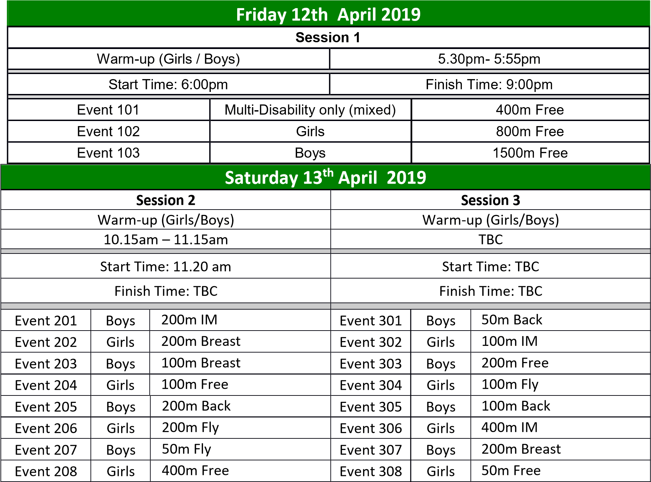

 | Sunday 14th April 2019
 | Session 4 |  | Session 5
 | Warm-up (Girls/Boys) |  | Warm-up (Girls/Boys)
 | 10.15am – 11.15am |  | TBC
 | Start Time: 11:20 am |  | Start Time: TBC
 | Finish Time: TBC |  | Finish Time: TBC
Event 401 | Girls | 50m Back | Event 501 | Girls | 200m IM
Event 402 | Boys | 100m Free | Event 502 | Boys | 100m Fly
Event 403 | Girls | 100m Breast | Event 503 | Girls | 100m Back
Event 404 | Boys | 200m Fly | Event 504 | Boys | 50m Breast
Event 405 | Girls | 200m Free | Event 505 | Girls | 50m Breast
Event 406 | Boys | 100m IM | Event 506 | Boys | 400m IM
Event 407 | Girls | 200m Back | Event 507 | Girls | 50m Fly
Event 408 | Boys | 400m Free | Event 508 | Boys | 50m Free
Please refer to attached upper and lower time limits for age eligibility in certain events Signing in closes 10 minutes before warm up for each session
Notes:
- Allocated warm-up times (i.e. age group) will be advised on the day.
- All events are Heat Declared Winners.
- Medals to be collected from presentation desk.
- There will be a presentation for Top Club at the end of session
- The combined maximum length of sessions will be 7.5 hours per day.

Gloucester City Level 2 Open Meet Lower Qualifying times

No swimmer with a time slower than the qualifying time may enter that event

BOYS | 9 | 10 | 11 | 12 | 13 | 14 | 15 | 16+
50m Free | 42.10 | 39.30 | 37.20 | 35.10 | 33.10 | 31.30 | 29.90 | 29.00
100m Free | 1:29.80 | 1:23.00 | 1:20.60 | 1:15.70 | 1:11.10 | 1:07.30 | 1:04.60 | 1:02.60
200m Free | 3:22.80 | 3:06.00 | 2:54.80 | 2:44.70 | 2:35.00 | 2:26.60 | 2:20.80 | 2:16.30
400m Free | 7:20.60 | 6:31.80 | 6:06.00 | 5:46.00 | 5:26.80 | 5:10.40 | 4:57.50 | 4:48.70
1500m Free |  |  | 23:37.90 | 22:20.50 | 21:30.50 | 19:56.90 | 19:07.70 | 18:49.00
50m Breast | 55.10 | 51.30 | 48.00 | 45.10 | 41.90 | 39.60 | 37.70 | 36.40
100m Breast | 1:55.70 | 1:48.50 | 1:43.40 | 1:36.90 | 1:30.10 | 1:25.10 | 1:21.00 | 1:18.40
200m Breast | 4:17.80 | 3:59.00 | 3:42.40 | 3:29.20 | 3:15.20 | 3:03.90 | 2:55.80 | 2:50.70
50m Fly | 47.40 | 43.80 | 41.00 | 38.80 | 36.40 | 34.30 | 32.50 | 31.50
100m Fly | 1:40.00 | 1:34.50 | 1:30.40 | 1:24.60 | 1:19.10 | 1:14.40 | 1:10.70 | 1:08.80
200m Fly | 4:08.30 | 3:37.30 | 3:18.20 | 3:06.60 | 2:54.70 | 2:44.70 | 2:35.50 | 2:31.70
50m Back | 48.60 | 45.10 | 42.50 | 40.30 | 37.60 | 35.80 | 33.90 | 32.60
100m Back | 1:39.90 | 1:33.60 | 1:30.50 | 1:25.20 | 1:19.70 | 1:15.00 | 1:11.50 | 1:09.30
200m Back | 3:43.80 | 3:26.70 | 3:13.30 | 3:02.60 | 2:51.10 | 2:41.40 | 2:34.30 | 2:29.80
100m IM | 1:41:00 | 1:36:00 | 1:28:00 | 1:22:00 | 1:17:00 | 1:13:00 | 1:08:00 | 1:05:00
200m IM | 3:49.70 | 3:32.20 | 3:17.60 | 3:06.80 | 2:55.80 | 2:45.30 | 2:38.20 | 2:33.70
400m IM |  |  | 6:59.70 | 6:34.30 | 6:12.00 | 5:50.30 | 5:34.60 | 5:25.40

GIRLS | 9 | 10 | 11 | 12 | 13 | 14 | 15 | 16+
50m Free | 42.60 | 39.90 | 37.70 | 35.70 | 34.30 | 33.30 | 32.50 | 32.00
100m Free | 1:30.60 | 1:27.60 | 1:21.30 | 1:16.60 | 1:13.50 | 1:11.30 | 1:09.90 | 1:08.70
200m Free | 3:24.50 | 3:06.80 | 2:55.40 | 2:44.90 | 2:38.00 | 2:33.50 | 2:30.20 | 2:28.00
400m Free | 7:25.40 | 6:35.70 | 6:04.90 | 5:43.70 | 5:29.80 | 5:20.80 | 5:13.80 | 5:10.20
800m Free |  |  | 11.14.00 | 10:34.90 | 10.07.80 | 9:56.20 | 9:53.50 | 9:48.90
50m Breast | 55.90 | 51.70 | 48.30 | 45.40 | 43.20 | 41.80 | 40.80 | 40.30
100m Breast | 1:59.90 | 1:52.50 | 1:43.50 | 1:37.30 | 1:32.30 | 1:28.70 | 1:27.10 | 1:26.20
200m Breast | 4:20.00 | 3:59.50 | 3:42.10 | 3:28.80 | 3:18.20 | 3:11.50 | 3:07.90 | 3:05.80
50m Fly | 47.90 | 43.90 | 41.30 | 39.10 | 37.30 | 36.10 | 35.20 | 34.70
100m Fly | 1:47.90 | 1:39.30 | 1:30.90 | 1:24.90 | 1:21.20 | 1:18.30 | 1:16.90 | 1:15.80
200m Fly | 4:11.00 | 3:40.00 | 3:20.20 | 3:06.40 | 2:57.30 | 2:51.00 | 2:46.90 | 2:44.80
50m Back | 48.90 | 45.30 | 42.70 | 40.50 | 38.70 | 37.50 | 36.80 | 36.10
100m Back | 1:45.50 | 1:38.50 | 1:31.00 | 1:25.30 | 1:21.40 | 1:19.00 | 1:17.10 | 1:16.10
200m Back | 3:46.20 | 3:28.70 | 3:12.50 | 3:01.70 | 2:54.30 | 2:49.20 | 2:44.80 | 2:42.40
100m IM | 1:41:00 | 1:36:00 | 1:28:00 | 1:23:00 | 1:18:50 | 1:14:00 | 1:10:00 | 1:08:00
200m IM | 3:51.60 | 3:32.70 | 3:17.90 | 3:06.30 | 2:58.80 | 2:53.10 | 2:49.50 | 2:47.20
400m IM |  |  | 6:57.30 | 6:32.00 | 6:14.40 | 6:03.10 | 5:55.80 | 5:50.50

Swimmers must have achieved a current ranking time equal to or faster than the times shown above in the qualifying table. This can be a short course or converted long course time. Entry times will be subject to random checking. Any swimmer found to have fabricated an entry time will be removed from the meet without refund.

Gloucester City Level 3 Open Meet Upper Qualifying times
No swimmer with a time faster than the upper qualifying time may enter that event

BOYS | 9 | 10 | 11 | 12 | 13 | 14 | 15 | 16+
50m Free | 42.11 | 39.31 | 37.21 | 35.11 | 33.11 | 31.31 | 29.91 | 29.01
100m Free | 1:29.81 | 1:23.01 | 1:20.61 | 1:15.71 | 1:11.11 | 1:07.31 | 1:04.61 | 1:02.61
200m Free | 3:22.81 | 3:06.01 | 2:54.81 | 2:44.71 | 2:35.01 | 2:26.61 | 2:20.81 | 2:16.31
400m Free | 7:20.61 | 6:31.81 | 6:06.01 | 5:46.01 | 5:26.81 | 5:10.41 | 4:57.51 | 4:48.71
1500m Free |  |  | 23:37.91 | 22:20.51 | 21:30.51 | 19:56.91 | 19:07.71 | 18:49.01
50m Breast | 55.11 | 51.31 | 48.01 | 45.11 | 41.91 | 39.61 | 37.71 | 36.41
100m Breast | 1:55.71 | 1:48.51 | 1:43.41 | 1:36.91 | 1:30.11 | 1:25.11 | 1:21.01 | 1:18.41
200m Breast | 4:17.81 | 3:59.01 | 3:42.41 | 3:29.21 | 3:15.21 | 3:03.91 | 2:55.81 | 2:50.71
50m Fly | 47.41 | 43.81 | 41.01 | 38.81 | 36.41 | 34.31 | 32.51 | 31.51
100m Fly | 1:40.01 | 1:34.51 | 1:30.41 | 1:24.61 | 1:19.11 | 1:14.41 | 1:10.71 | 1:08.81
200m Fly | 4:08.31 | 3:37.31 | 3:18.21 | 3:06.61 | 2:54.71 | 2:44.71 | 2:35.51 | 2:31.71
50m Back | 48.61 | 45.11 | 42.51 | 40.31 | 37.61 | 35.81 | 33.91 | 32.61
100m Back | 1:39.91 | 1:33.61 | 1:30.51 | 1:25.21 | 1:19.71 | 1:15.01 | 1:11.51 | 1:09.31
200m Back | 3:43.81 | 3:26.71 | 3:13.31 | 3:02.61 | 2:51.11 | 2:41.41 | 2:34.31 | 2:29.81
100m IM | 1:41:01 | 1:36:01 | 1:28:01 | 1:22:01 | 1:17:01 | 1:13:01 | 1:08:01 | 1:05:01
200m IM | 3:49.71 | 3:32.21 | 3:17.61 | 3:06.81 | 2:55.81 | 2:45.31 | 2:38.21 | 2:33.71
400m IM |  |  | 6:59.71 | 6:34.31 | 6:12.01 | 5:50.31 | 5:34.61 | 5:25.41

GIRLS | 9 | 10 | 11 | 12 | 13 | 14 | 15 | 16+
50m Free | 42.61 | 39.91 | 37.71 | 35.71 | 34.31 | 33.31 | 32.51 | 32.01
100m Free | 1:30.61 | 1:27.61 | 1:21.31 | 1:16.61 | 1:13.51 | 1:11.31 | 1:09.91 | 1:08.71
200m Free | 3:24.51 | 3:06.81 | 2:55.41 | 2:44.91 | 2:38.01 | 2:33.51 | 2:30.21 | 2:28.01
400m Free | 7:25.41 | 6:35.71 | 6:04.91 | 5:43.71 | 5:29.81 | 5:20.81 | 5:13.81 | 5:10.21
800m Free |  |  | 11.14.01 | 10:34.91 | 10.07.81 | 9:56.21 | 9:53.51 | 9:48.91
50m Breast | 55.91 | 51.71 | 48.31 | 45.41 | 43.21 | 41.81 | 40.81 | 40.31
100m Breast | 1:59.91 | 1:52.51 | 1:43.51 | 1:37.31 | 1:32.31 | 1:28.71 | 1:27.11 | 1:26.21
200m Breast | 4:20.01 | 3:59.51 | 3:42.11 | 3:28.81 | 3:18.21 | 3:11.51 | 3:07.91 | 3:05.81
50m Fly | 47.91 | 43.91 | 41.31 | 39.11 | 37.31 | 36.11 | 35.21 | 34.71
100m Fly | 1:47.91 | 1:39.31 | 1:30.91 | 1:24.91 | 1:21.21 | 1:18.31 | 1:16.91 | 1:15.81
200m Fly | 4:11.01 | 3:40.01 | 3:20.21 | 3:06.41 | 2:57.31 | 2:51.01 | 2:46.91 | 2:44.81
50m Back | 48.91 | 45.31 | 42.71 | 40.51 | 38.71 | 37.51 | 36.81 | 36.11
100m Back | 1:45.51 | 1:38.51 | 1:31.01 | 1:25.31 | 1:21.41 | 1:19.01 | 1:17.11 | 1:16.11
200m Back | 3:46.21 | 3:28.71 | 3:12.51 | 3:01.71 | 2:54.31 | 2:49.21 | 2:44.81 | 2:42.41
100m IM | 1:41:01 | 1:36:01 | 1:28:01 | 1:23:01 | 1:18:51 | 1:14:01 | 1:10:01 | 1:08:01
200m IM | 3:51.61 | 3:32.71 | 3:17.91 | 3:06.31 | 2:58.81 | 2:53.11 | 2:49.51 | 2:47.21
400m IM |  |  | 6:57.31 | 6:32.01 | 6:14.41 | 6:03.11 | 5:55.81 | 5:50.51

